W01 Challenge:

Part 1: What is spatial analysis?

Spatial analysis is how human beings understand and relate to their surroundings. We use our senses to gather information about our environment and use those assumptions to make decisions, detect patterns, create maps, and go about our daily lives.

Part 2: Using the language of spatial analysis:

As with any other technical field, we need a way to communicate our thoughts into ways that other people can understand. Using specified language (the language of spatial analysis), we are able to do that effectively.

1. Understanding where:
   1. Understanding where things are (location maps)

* Where is the Statue of Liberty?
  1. Understanding where the variations and patterns in values are (comparative maps)
* Which country has the lowest rate of drug related arrests?
  1. Understanding where and when locations and values change
* Do weather patterns influence the amount of people that visit a certain landmark during different seasons?

1. Measuring size, shape, and distribution:
   1. Calculating individual feature geometries

* What is the area of Eurasia measured in meters?
  1. Calculating geometries and distributions of feature collections
* Can the location of cell towers allow authorities to triangulate and locate a certain person’s cell phone?

1. Determining how places are related:
   1. Determining what is nearby or coincident

* How many apartment complexes are less than one block away from the BYUI campus?
  1. Determining and summarizing what is within an area
* How many subway stations are within 10km of the Sears Tower?
  1. Determining what is closest
* Where is the closest grocery store?
  1. Determining what is visible from a given location
* How many cars are visible from the top of the Eiffel Tower?
  1. Determining overlapping relationships in space and time
* When/where will domestic/international flights overlap with migrating bird paths?

1. Finding the best locations and paths:
   1. Finding the best locations that satisfy a set of criteria

* Which location is best to build a new hotel in Aruba?
  1. Finding the best allocation of resources to geographic areas
* Where should California place dams/reservoirs in order to provide its citizens with enough water?
  1. Finding the best route, path, or flow along a network
* What is the fastest route to drive to Dallas, Texas?
  1. Finding the best route, path, or corridor across open terrain
* What’s the fastest route from the most northern point of Antarctica to the most southern point?
  1. Finding the best supply locations given known demand and a travel network
* Which harbors have the highest supply of oysters that are within a 500 miles radius of Phoenix?

1. Detecting and quantifying patterns:
   1. Where are the significant hot spots, anomalies, and outliers?

* Are there clusters of people diagnosed with radiation sickness whose addresses are within 5 miles of 5G cell towers?
  1. What are the local, regional, and global spatial trends?
* Is the population distribution increasing at the same rate on a local, regional, and global scale?
  1. Which features/pixels are similar, and how can they be clustered, classified, and identified?
* What major cities around the world have the same vulnerability to floods and other water hazards?
  1. Are spatial patterns changing over time?
* Are wolf distributions in the Northwestern USA becoming more dispersed over time?

1. Making predictions:
   1. Given a success case, identifying, ranking, and predicting similar locations

* If gypsum is found in a certain playa lake, can the attributes of the environment help us to predict other gypsum deposits?
  1. Finding the factors that explain observed spatial patterns and making predictions
* What factors create a higher risk of drug addiction and how can local organizations mitigate these factors?
  1. Interpolating a continuous surface and trends from discrete sample observations
* What unsolved murder cases from the 1980s share similar characteristics across the United States?
  1. Predicting how and where objects spatially interact (attraction and decay)
* Does the size of a casino in Las Vegas correlate with how many people gamble there each night?
  1. Predicting how and where objects affect wave propagation
* How will breakers on the coast of a city affect sand distribution along the rest of the coast?
  1. Predicting where phenomena will move, flow, or spread
* If California relaxes its mask mandate, will Covid-19 transmission rates increase?
  1. Predicting what-if
* Would the presence of a serial killer in a moderately sized town influence the amount of people that regularly visit local restaurants?

Part 3: Applying the language of spatial analysis:

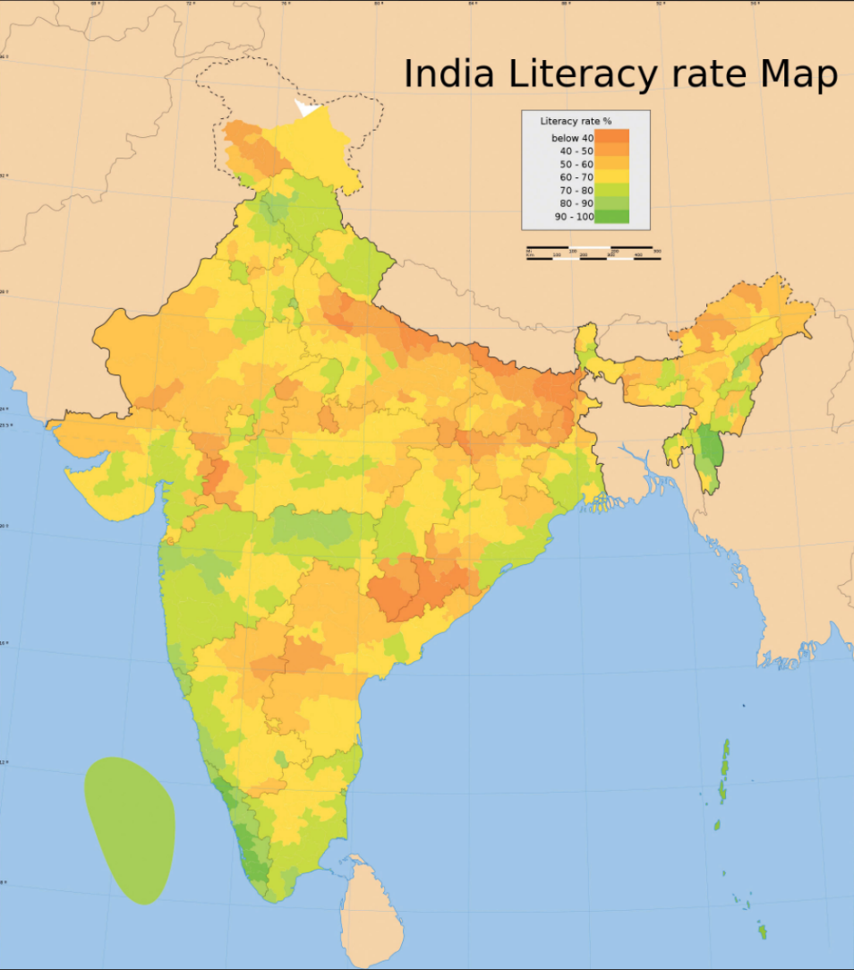

In which types of areas is India’s literacy rate higher? Is this rate influenced by population distribution?